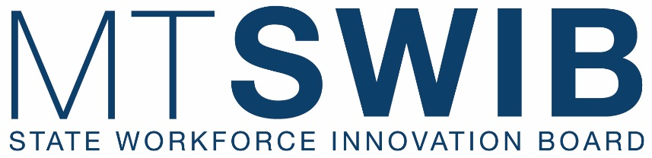

Full Board Quarterly Meeting
May 22, 2024
University of Montana
Todd Building Room 203
Missoula, MT
Remote Link: Zoom
______________________________________________________________________________
AGENDA
(Times and Items are Subject to Change)

7:30 a.m. PRE-MEETING CONTINENTAL BREAKFAST

8:00 a.m. CALL TO ORDER CHAIR HOPFAUF

ROLL CALL JENNIFER OWEN AND CHAIR HOPFAUF

AGENDA CHAIR HOPFAUF
- Review and Action of Meeting Agenda
(Action Item: Approve/Deny/Table)

LAST MEETING MINUTES CHAIR HOPFAUF
- Review and Action of January Minutes
(Action Item: Approve/Deny/Table)

8:10 a.m. MISSOULA ECONOMIC PARTNERSHIP CHAIR HOPFAUF
- Discussion of projects and opportunities

9:00 a.m. MT DLI COMMISSIONER VISION COMMISSIONER SWANSON

9:10 a.m. WIOA FUNDING ALLOCATIONS BARB WAGNER
- Action Item: Approve/Deny/Table
  - Public Comment Prior to Vote

9:20 a.m. BREAK

9:30 a.m. HEADWATERS TECHHUB ACTION PLAN CHAIR HOPFAUF
- Remarks from Commerce Director Paul Green
- Review of Summit
- Develop Action Items & Next Steps
- Action Item: Approve/Deny/Table
  - Public Comment Prior to Vote

10:30 a.m. SWIB GOALS AND PRIORITIES JENNIFER OWEN
- Governor’s SkillUp Montana Initiative (Dylan Klapmeier)
- Develop Action Items & Next Steps
- Action Item: Approve/Deny/Table
  - Public Comment Prior to Vote

11:30 a.m. LUNCH

12:15 p.m. DEPART FOR TOUR OF MISSOULA PRE-RELEASE CENTER
(Closed to the Public)

12:30 p.m. OFFENDER REENTRY INITIATIVES DIRECTOR BRIAN GOOTKIN

2:00 p.m. RETURN TO UM CAMPUS

2:15 p.m. YOUTH PROGRAMS DISCUSSION

3:20 p.m. SWIB CHAIR CLOSING REMARKS CHAIR HOPFAUF

3:25 p.m. PUBLIC COMMENT ON NON-AGENDA ITEMS

3:30 p.m. ADJOURNMENT CHAIR HOPFAUF

