
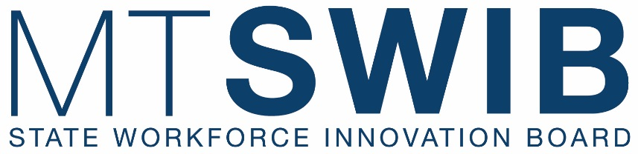

SWIB Quarterly Meeting
April 27, 2026
10:30 a.m. to 4:00 p.m.
April 28, 2026
8:30 a.m. to 3:30 p.m.

Location: MSU-Bozeman
Strand Union Building – Ballroom D
751 W. Grant Street, Bozeman, MT 59715

Remote Link: Join the meeting now

AGENDA
(Times and Items are Subject to Change)

APRIL 27, 2026

10:30 a.m. CALL TO ORDER CHAIR GILBERTSON

ROLL CALL/INTRODUCTIONS TAMMIE HICKEY

AGENDA CHAIR GILBERTSON
Review and Action of April 27 & 28 Agenda
(Action Item: Approve/Deny/Table)

LAST MEETING MINUTES CHAIR GILBERTSON
Review and Action of January, 2026 Minutes
(Action Item: Approve/Deny/Table)

PUBLIC COMMENT

10:40 a.m. DEPARTMENT OF LABOR & INDUSTRY UPDATES COMMISSIONER SWANSON

10:55 a.m. NATIONAL GOVERNOR’S ASSOCIATION CHAIR GILBERTSON
Opportunities to Align Systems for a Stronger Workforce: Best Practices from NGA
. Portia Pratt, Senior Policy Analyst, Post Secondary Education
Eric Aboodi, Policy Analyst

12:00 p.m. LUNCH BREAK

1:00 p.m. HB 823 STAKEHOLDER ENGAGEMENT CHAIR GILBERTSON
Susie Hedalen, Superintendent, Office of Public Instruction
Clay Christian, Commissioner, Office of Commission of Higher Education
Sarah Swanson, Commissioner, Department of Labor & Industry
Stakeholders: teachers, students, labor organizations, businesses, and institutions/agencies involved in vocational/technical education.

- discuss the state plan.
- identify any issues or concerns with the administration in Montana of the Strengthening Career and Technical Education for the 21st Century Act of 2018.
- identify the needs of students, employers, and career programs in Montana and determine the best way to meet those needs; and
- if necessary, make changes in the administration and operation in Montana of the Strengthening Career and Technical Education for the 21st Century Act of 2018 in Montana.

PUBLIC COMMENT

2:00 p.m. WIOA/Perkins Combined State Plan Mid-Cycle Update CHAIR GILBERTSON Crystal Armstrong, Deputy Director, Department of Labor & Industry
Jacque Treaster, Director, Office of Commission of Higher Education
Shannon Boswell, Director, Office of Public Instruction
Chanda Hermanson, Administrator, Department of Public Health & Human Services

PUBLIC COMMENT

3:00 p.m. WORKFORCE PELL PRESENTATION CHAIR GILBERTSON Jennifer Owen, Policy & Public Affairs Director, Department of Labor & Industry
Joe Thiel, Interim Deputy Commissioner, Office of Commission of Higher Education

PUBLIC COMMENT

4:00 p.m. ADJOURNMENT CHAIR GILBERTSON

5:30 p.m. Optional
Reception at the American Computers & Robotics Museum (5:30 p.m. – 7:00 p.m.)
2023 Stadium Drive, Suite 1-A, Bozeman, MT 59715

APRIL 28, 2026

8:30 a.m. Optional
Tour of Williams Plumbing Training Academy (8:30 a.m. - 9:30 a.m.)
370 Companion Way, Belgrade, MT 59714

10:30 a.m. CALL TO ORDER CHAIR GILBERTSON

ROLL CALL TAMMIE HICKEY
WORKFORCE SYSTEM CHAIR GILBERTSON

- WIOA/Perkins Mid-Cycle Plan Approval

Review and Action
(Action Item: Approve/Deny/Table)

- WIOA Competitive Subrecipient Funding Opportunity Framework:
Crystal Armstrong/Chris Bradley, Department of Labor & Industry
WIOA Title I: Youth Program
WIOA Title I: Adult Program
WIOA Title I: Dislocated Worker Program
WIOA Title II: Adult Education and Family Literacy Act Program

Review and Action
(Action Item: Approve/Deny/Table)

- WORKFORCE Pell Recommendation

Review and Action
(Action Item: Approve/Deny/Table)

PUBLIC COMMENT

12:00 p.m. LUNCH BREAK

1:00 p.m. AI/AUTOMATION DISCUSSION PANEL with industry guests JASON YAGER Chris Tarrabochia, Chief AI Officer, Department of Administration
Jason Neiffer, Executive Director, Montana Digital Academy
Joe Thiel, Interim Deputy Commissioner, Office of Commission of Higher Education

2:30 p.m. 406 JOBS HIGHLIGHTS CHAIR GILBERTSON
- Sector Partnerships
Sector Reports, Tammie Hickey, SWIB Director
Health Careers/RHTP,

- JMG/Empowered Pathways
Heather Merritt, JMG, Department of Labor & Industry
James Easton, Empowered, MT Chamber of Commerce

- Registered Apprenticeships
Advisory Council, Tammie Hickey, SWIB Director
Licensing Task Force, Erin Sullivan, Policy Analyst, Department of Labor & Industry

PUBLIC COMMENT CHAIR GILBERTSON

CHAIR CLOSING REMARKS CHAIR GILBERTSON

3:30 p.m. ADJOURNMENT CHAIR GILBERTSON

