
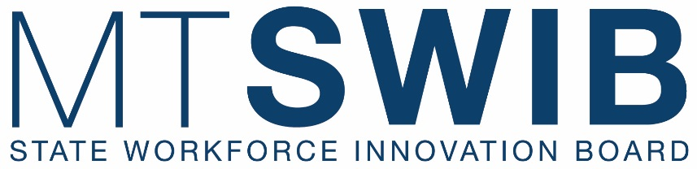

Executive Committee Meeting
March 24, 2026
2:00 p.m.
Remote Link: Join the meeting now

______________________________________________________________________________
AGENDA
(Times and Items are Subject to Change)

2:00 p.m. CALL TO ORDER CHAIR GILBERTSON

ROLL CALL TAMMIE HICKEY

AGENDA CHAIR GILBERTSON
- Review and Action of March Agenda
(Action Item: Approve/Deny/Table)

PRIOR MEETING MINUTES CHAIR GILBERTSON
- Review and Action of December Minutes
(Action Item: Approve/Deny/Table)

PUBLIC COMMENT ON AGENDA ITEMS CHAIR GILBERSTON

FEDERAL UPDATES RACHEL GREEN

WORKFORCE SYSTEM UPDATES CHAIR GILBERTSON
- WIOA State Plan (Crystal)
- Perkins Planning Committee (Tammie)
- Apprenticeship Advisory Council Update (Tammie)
- Workforce Pell Updates (Jennifer)
- RHTP Update (Jennifer)
- Grants Update (Jennifer)

GENERAL COMMITTEE DISCUSSION CHAIR GILBERTSON
- April Meeting Agenda
- Updated SWIB List
- 406 JOBS Sub-Committees Update (Tammie)

PUBLIC COMMENT ON NON-AGENDA ITEMS CHAIR GILBERTSON

ADJOURNMENT CHAIR GILBERTSON

